OSINT Challenge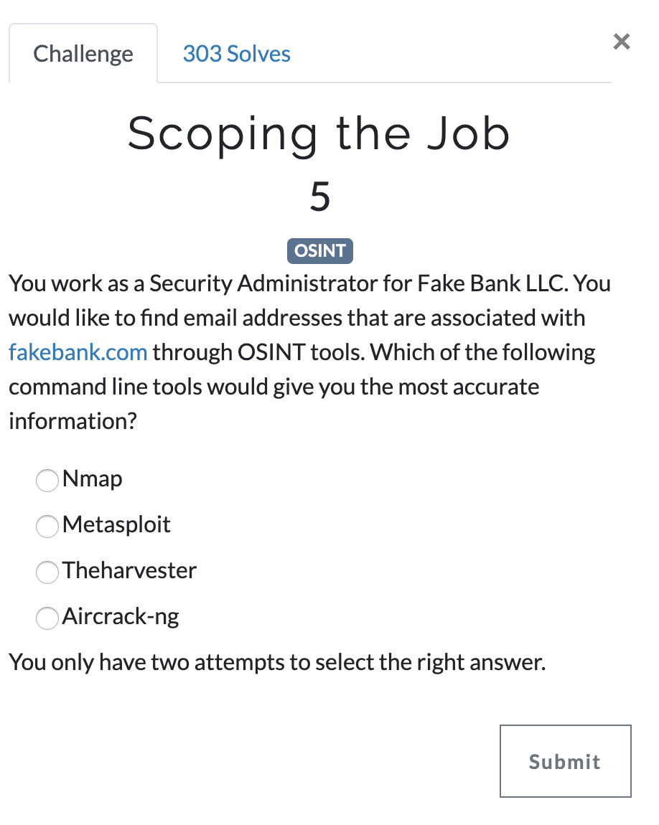
Answer: Theharvester

